Every few seconds traffic incident responders put their lives on the line to aid crash victims and traffic incidents such as stalled vehicles or roadway debris. When approaching responders, slow down, move over, it’s the law!
Slow Down. Move Over.
Lives Are On The Line.
CRASH RESPONDER SAFETY WEEK | NOVEMBER 2-6, 2026
Crash Responder Safety Week (CRSW) is an opportunity to spotlight that Move Over and Driver Removal laws save lives. As a responder, it’s a good reminder to complete the Traffic Incident Management (TIM) training and become a CRSW Champion.
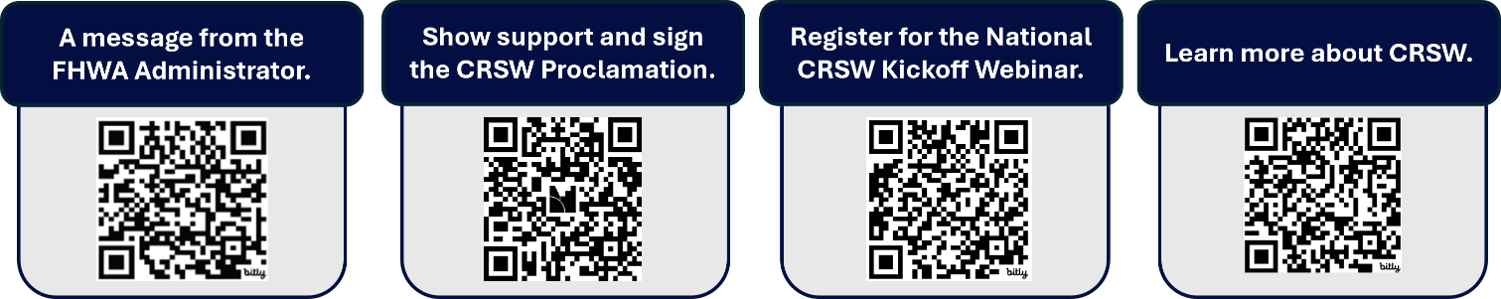
CRSW Resources. Learn more about CRSW resources by scanning the QR Codes below.

SPACE INCLUDED BELOW FOR PARTNER MESSAGING/LOGOS BEFORE DISTRIBUTION.



@FederalHighwayAdmin
Insert Agency Handle

@FederalHighwayAdmin
Insert Agency Handle

@USDOTFHWA
Insert Agency Handle

